The importance of marketing in launching a product

On the Télé set:
Claire (presenter): hello and welcome to “Tele Marketing”. On today’s programme we will be looking at the importance of marketing. To discuss this we have a special guest directly from Bordeaux, Barbara SMITH! Hello, it’s a pleasure. Do have a seat. Did you have a good trip to the set?
Barbara: Oh yes, thank you.
Claire: For starters, we are going to have a short presentation on the dog food market by our reporter.
PART 1: market presentation
Reporter: yes indeed, I am going to talk about the dog food market. A growing market despite the crisis, and despite a significant 15% VAT increase on domestic animal food over the past 2 years. French consumers have begun to opt in favour of low prices, and are continuing to buy, however they are no longer going for unnecessary expenses. On average, a French consumer will spend 121€ a year on dog food. The main manufacturers, producers of pedigree products Royal Canin, Caniyou and Cesar, have developed a new concept which is modelled on human nutrition with balanced menus, gourmet recipes, and tasty, ‘lite’ formulas to diversify the market.
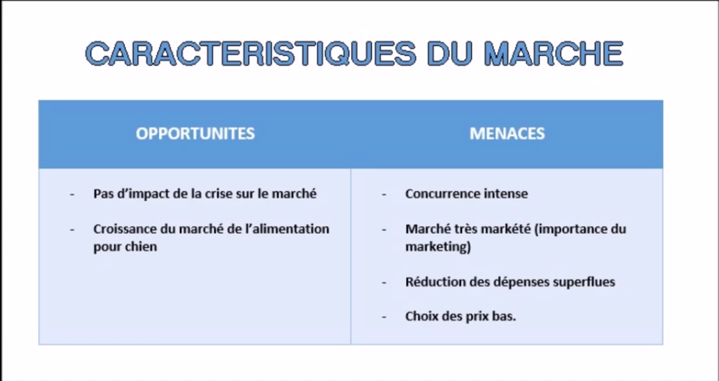
On the question of segmentation, out of a French population of 63,000,000 people, only 24% or about 15,120,000 persons own dogs. 33% of these persons have a “child dog” relationship with their dog, and consequently consider their animal a family member, preparing their meals themselves, with homemade dishes. 54% of persons have a “pet dog” relationship, and therefore consider their dog just a pet; they buy them manufactured food. And 13% of persons consider their dog a servant, so he’s just there to guard the house or work, and for food he just gets leftovers or scraps from the family.
PART 2: the idea behind the concept
Claire: to go right to the heart of the subject, we are going to see an interview between a marketing director trying to launch a product onto the market and our interviewer. However, we will see that there are a few small errors in this product launch, and Barbara is going to explain these errors and give reasons for them.
Barbara: Actually, we are going to interrupt the reporting at certain point to explain the marketing errors made by the marketing director.

Interview
Clothilde: For this interview we are going to discuss the stages of your product launch. What methods did you use to generate ideas? Did you carry out an unmet needs assessment, or did you use creativity techniques?
Morgane: No, this is a purely personal invention. I was the marketing director of a large soft drink manufacturing group. I had a dog. And I simply had the idea of a liquid food for dogs. So I did a comparison with the human market and I noticed that there were no sauces or soft drinks for dogs. That’s how I got the idea of a drink for dogs. And then, to explore this concept I did a study.
Clothilde: What methods did you use for this study?
Morgane: We had two group meetings and out of these came three concepts: the first is the soft drink for dogs, the second is the vitamin supplement and the third is the soup for dogs. We quickly abandoned the soft drink idea since it seemed too superficial. There was a lot of interest in the vitamin supplement but it seems consumers saw this as something for sick dogs or weak dogs. And then the niche market for this was too small. We were a lot more interested in the soup so we had another round table discussion and a several sentences were agreed upon. I’ll read them “It’s a change from water”; “it would be easy to use”; “it shouldn’t have too many calories”; “It would be beneficial for health”; “It would focus on taste”; “It would aid digestion”. The buyer is a young and dynamic person who wants to keep life simple.
Clothilde: But this is only the definition of the type of product. What product concept did you propose?
Morgane: Two solutions were presented to us: the taste addition or the nutritional supplement. For the taste addition we were focusing more on the pleasure aspect, making the dog happy whereas with the nutritional supplement it was more concern for the health of one’s dog.
PART 3: Segmentation and positioning
Morgane: I felt we could bank on the two promises because I felt my product could be both calorie-rich and tasty. This was a potentially large market for us since I could bank on dry foods with the taste addition on the one hand, and the homemade prepared food with the nutritional supplement on the other; especially since the homemade prepared food market was not being exploited by manufacturers. So I had a major goal, I wanted to make my product an everyday product.
Clothilde: So, we have seen how the concept was defined. With regard to the target market, what segmentation variables did you use?
Morgane: I was essentially targeting middle-class owners with feed produced from mostly dry products. So our target was more the affluent households in urban or peri-urban areas.
Clothilde: You describe the target market in terms of sociodemographic criteria, but you have not used traditional market typology: child dog, pet dog, servant dog.
Morgane: What I mean is that our product is for the “pet dog” as well as the “child dog”. In the case of the “pet dog” the composition of the product is what justifies its price. In the case of the “child dog”, we are focusing more on the taste aspect of the product, pleasing one’s dog”.

On the set
Claire: So Barbara, what do you think?
Barbara: Actually, the director happens to be trying to accomplish two objectives at once. In effect, the soup for dogs seems to be finding its place in the market in the “master-pet dog” relationship, but does not seem appropriate for the owner of the child dog since this owner pays a lot of attention to his dog’s meals and will therefore not be interested in manufactured products. In the group meeting, the idea of a simple, convenient product is associated with a young, dynamic buyer who wants to keep life simple. In other words, basically, he is not a “child dog” owner. He is, however, a “pet dog” owner. So, at the moment, his idea would be to make his dog happy but only occasionally. By targeting everyone, the manager risks failing to reach anyone, because in marketing, identifying a target customer base is vital to the success of the project.
PART 4: Positioning statement
Interview
Clothilde: Now that we have seen the marketing strategy, let’s move on to articulating the brand name, positioning, image, etc. What did you choose?
Morgane: For the brand name we held a brainstorming session. Over 50 names came out of this. We eliminated the ones that weren’t trendy. Out of these 20 names remained. There were names calling to mind the category of product, the canine environment or simply the benefits: taste or health. In collaboration with the agency we agreed on six names: Canibouillon, Vit’soup, Vitasoup, Punchy, Tasty and Gusty. Many of these names conjured up the benefits. For example, Vitasoup for vitality; Punchy, Tasty and Gusty for taste instead; Caniboullon was suggestive of the type of product and Vit’soup suggested convenience. From there the agency submitted three mock-ups.
I chose Gusty and registered the name.
Clothilde: Gusty suggests taste and pleasure. Don’t you think this contradicts the dual promise of taste complement and health supplement?

On the set
Barbara: Exactly! On all fronts, using a single name to express two benefits that are so different and very complicated. If you really want to keep the two promises, the solution would have been to use the name to express only the unique feature of the product, as with Canibouillon, for example.
Interview
Morgane: For the graphics, we wavered for a long time between two options: The first option was to fall in line with market convention and the second option was to set ourselves apart from it. To do this, the agency prepared two mock-ups.
We decided to stick with pet food convention because with the other option we were afraid of marginalising the product. So pet food market convention with a rather nice, average-sized dog, of no particular breed. And here’s the result.

On the set
Barbara: The graphic chosen does not adequately take into account the unique nature of the product. Sure, if you look closely you can see mentioned “it’s not too early”, but you really have to look hard before you realise this. In fact, by not wanting to take a risk, the effect was reversed, since you ran the risk of being overlooked in a linear market that is very congested.

Interview
Clothilde: You are staying with pet food convention, but you haven’t stated the precise purpose of the product…
Morgane: Good point ! Even so, it’s written on the back of the product packaging.

On the set
Barbara: actually, this is a problem, but that’s not all. A moment ago we saw that the manager wanted to make her soup an everyday product. In fact, we can see “essential” written at the bottom of the box, but it is not very visible. This was admittedly a very ambitious objective. But in marketing, you either believe in it and go for it, or stay out of the game.

Interview
Clothilde: did you conduct any studies before launching the product?
Morgane: Yes, we did quantitative studies to confirm buyers’ receptiveness to the product and we had very encouraging results since half of the buyers said they were in favour of the product.
PART 5: Distribution and communications
Clothilde: For the Mix Marketing, what did you do? You must have encountered several problems?
Morgane: Actually, there were many problems. Fortunately, I had help from Le Goncourt at the Toulouse veterinary school in manufacturing the product and in carrying out taste tests on the dogs. Out of this we brought out two products: a meat soup and a vegetable soup.
Clothilde: What did you do?
We didn’t hesitate to choose a carton since it’s a very successful material. We ruled out glass bottles since they had too much of a beverage connotation, as well as tin cans because they had a strong connotation of mash. However, we hesitated on the format, either 1 L at 2.07€ or 3 packs of 25 cl but we felt the packaging costs were much too high at 2.94€, so we chose the litre.

On the set
Barbara: Choosing the litre is consistent with the desire to market an everyday product, but the buyer who starts on a 1-litre box will need to use it quickly. On average, the price of a basic dry meal (like biscuits) is 57 cents more or less. When drizzled with sauce, the price goes up to 1.14€, or double, so price becomes a big obstacle for the regular buyer. On the other hand, with three separate portions, the buyer opts for the logic of an occasional treat, and the magnitude of the price obstacle becomes greatly reduced.

Interview
Clothilde: We have just seen the first two P’s in the marketing mix: product and price. For promotion, the third P, what was your budget?
Morgane: We had a total budget of 500,000€. In the beginning I had not made an allowance for media publicity because I felt we at least needed market penetration to be able to do this. After a year went by, I had intended to do this because we had a bit of market penetration. However, I did put a lot of effort into sales promotions, for example, with money-back offers. I also did a lot of press and public relations. I took my products to vets and opinion-leaders such as the animal protection society and breeders.
Clothilde: And what about distribution?
Morgane: I went to the purchasing cooperatives myself. I recruited a sales team for the other rounds and retailer visits. I got an amazing response from the buyers. There are two reasons for this. The first is the novelty of the product; the second is that they had to make additional sales rather than substitution sales. Let me quote you a figure: in 7 months, I made 80% of ND (numeric distribution) in Hyper stores.
PART 6: response and results
Clothilde: Do you think this was a success?
Morgane: The placement was a success; on the other hand, the repurchases did not go well.
Clothilde: The reasons for the poor performance?
Morgane: Yes, we did a study on a small sample: the results were very clear. There was a defect in the product. The substance was accumulating at the bottom of the carton and buyers thought they were pouring coloured water for their dogs. In addition, the dogs weren’t showing any particular signs of contentment so the buyers felt they had been conned.
Clothilde: What was your response?
Morgane: We reviewed the entire manufacturing process for the product. In addition, I realised that my dual promise was unrealistic and with new positioning, we promoted the advantage of taste. We created new packaging. Furthermore, I gave up the idea of making Gusty an everyday product and with this positioning we replaced the litre size with a 25 cl three-pack. Next, we created a new “beef marrow” variety to push the advantage of taste; which is what makes dogs happy. Finally, I invested in television advertising.

On the set
Clothilde: So Barbara, does this new positioning seem better to you?
Barbara: Well, the idea has made headway; this new approach seems decidedly better; unfortunately, we will never know what it could have generated, since on its relaunch, the company was abandoned by its bankers.
Clothilde: Thank you, Barbara, for this presentation and for joining us on the programme. And you, dear viewer, I wish you a good evening and we thank you for watching this broadcast. See you next week, with a new episode of TéléMarketing.

